Install docker on EC2 and explore the docker commands (docker images, containers, volumes, network)

EC2 LAUNCH:

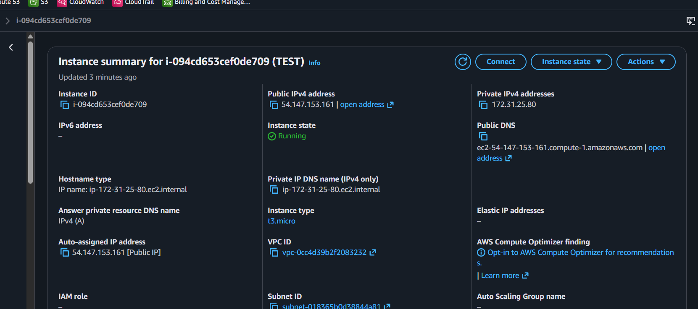

DOCKER INSTALLATION:

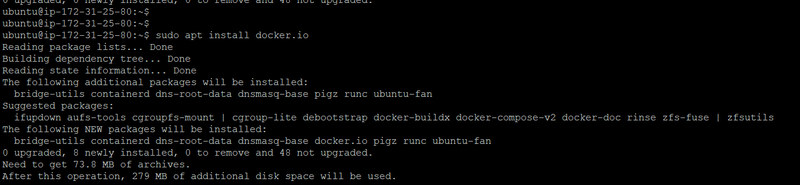

DOCKER STATUS:
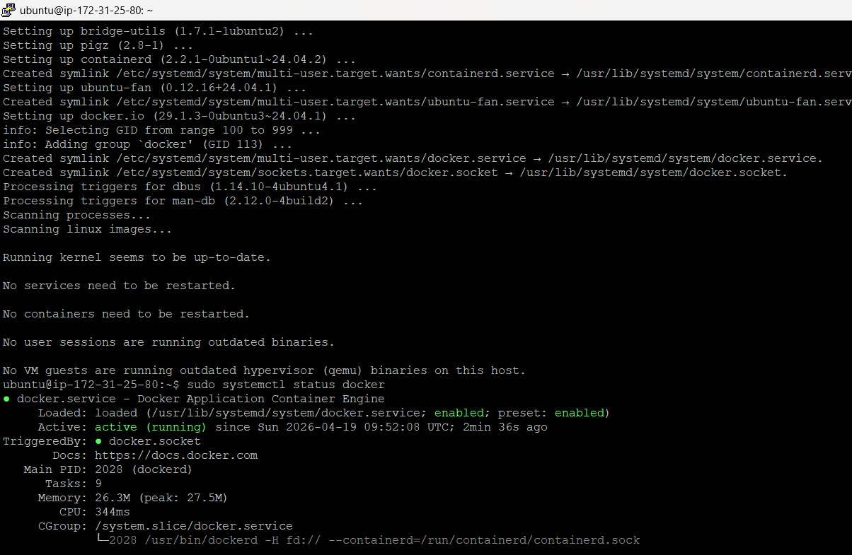

DOCKER VERSION:
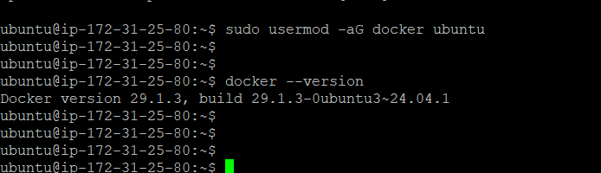

DOCKER IMAGES:
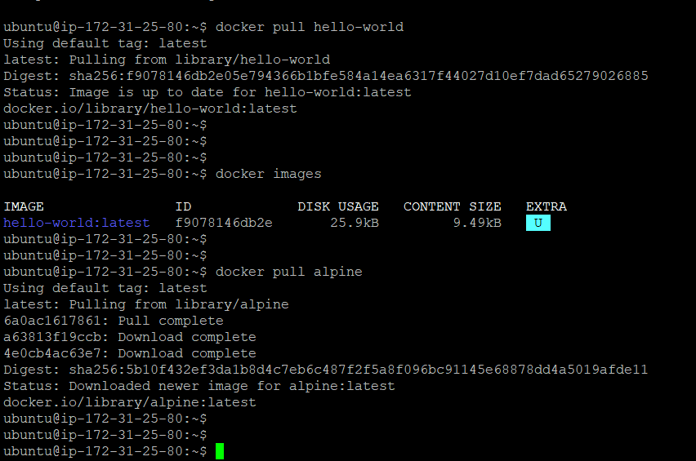

DOCKER CONTAINERS:

CREATING AND EXECUTING THE CONTAINER
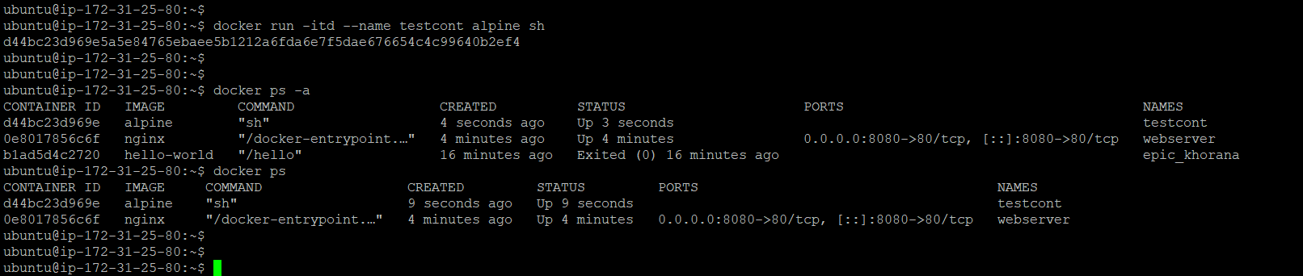

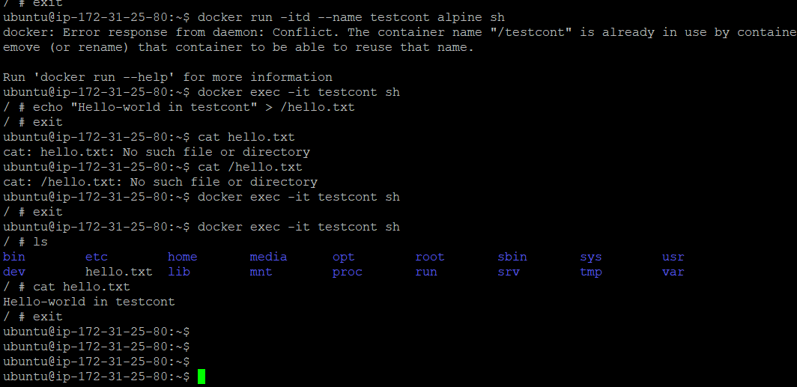

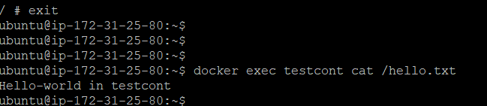

CREATE AND ATTTAC VOLUME:

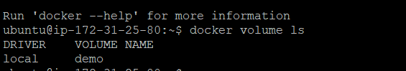

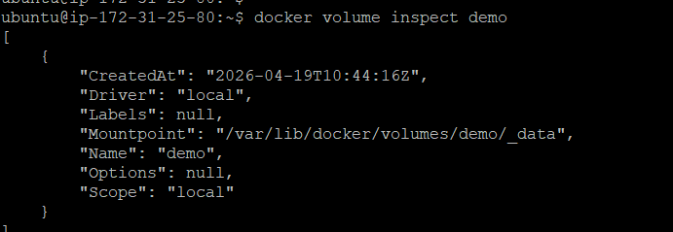

MOUNTING THE VOLUME INTO DIRECTORY IN NEW CONTAINER

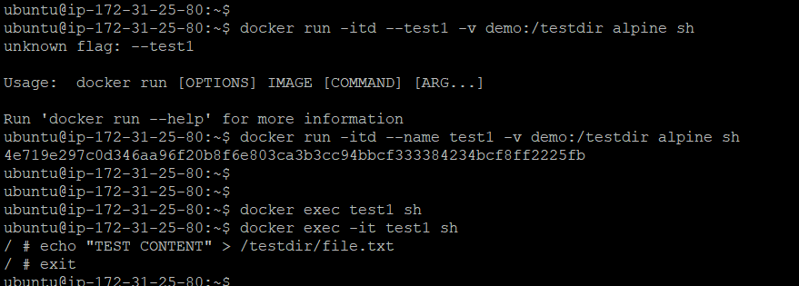

GOING INTO CONTAINER AND DIECTOTY. WE CAMN BE ABLE TO SEE THE FILE.TXT
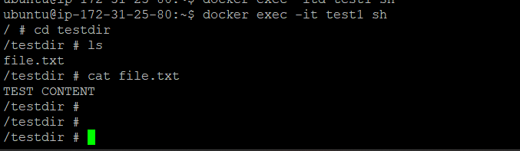

REMOVED THE NEW CONTAINER

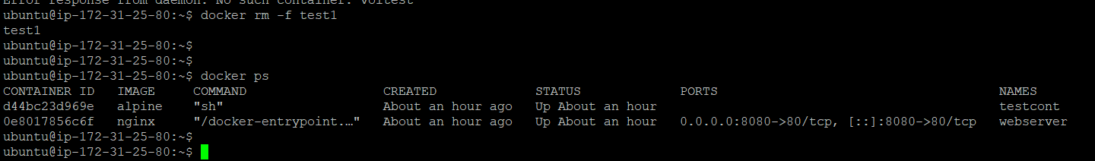

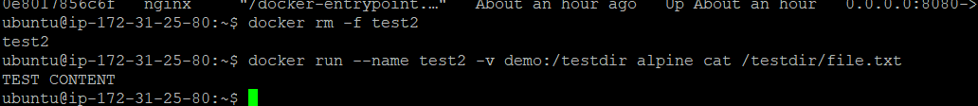

This shows that the file file.txt stored in the demo volume is still there.
Even though the old container was deleted, the data persisted in the volume.
The new container (test2) was able to read it immediately.

CONTAINER NETWORK

CREATE NETWORK AND COMMUNICATE NETWEEN THE CONTAINERS

